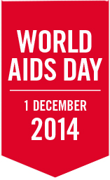

_{PRESS RELEASE}
Close the gap this World AIDS Day

On 1 December 2014, help to close the gap to end the AIDS epidemic by 2030
City, date—World AIDS Day 2014 is an opportunity to harness the power of social change to put people first and close the gap. Ending the AIDS epidemic by 2030 is possible, but only by closing the gap between people who have access to HIV prevention, treatment, care and support services and people who are being left behind.
Closing the gap means empowering and enabling all people, everywhere, to access the services they need.
- By closing the HIV testing gap, the 19 million people who are unaware of their HIV-positive status can begin to get support.
- By closing the treatment gap, all 35 million people living with HIV will have access to life-saving medicine.
- By closing the gap in access to medicines for children, all children living with HIV will be able to access treatment, not just the 24% who have access today.
- By closing the access gap, all people can be included as part of the solution.
Closing the gap means that ending the AIDS epidemic by 2030 is possible.

More information is available at:
#WAD2014
#CloseTheGap
Facebook
[END]

Contact
Organization | Name of person | tel. +00 00 00 00 00 | email address

